1-Front-End

Definition:
# Source: AI Source: Provided by: [Data Path: Persons Table -> ID Column: 1, Name_En Column: Motasem Essam] -> From: [Chatgpt (GPT‑5 Mini)] on [1/26/2026]
The front-end is the part of a software application or website that interacts directly with the user. It’s what users see, touch, and use—the “visual” part of the application.

Key Points
# Source: AI Source: Provided by: [Data Path: Persons Table -> ID Column: 1, Name_En Column: Motasem Essam] -> From: [Chatgpt (GPT‑5 Mini)] on [1/26/2026]
- Also called: Client-side
- Handles:
  - User interface (UI) – buttons, forms, menus
  - User experience (UX) – layout, responsiveness, animations
- Runs on: The user’s web browser or device, not the server

Front-End Technologies
# Source: AI Source: Provided by: [Data Path: Persons Table -> ID Column: 1, Name_En Column: Motasem Essam] -> From: [Chatgpt (GPT‑5 Mini)] on [1/26/2026]
- Web Development:
  - HTML → Structure of the page
  - CSS → Styling (colors, fonts, layout)
  - JavaScript → Interactivity and dynamic behavior
- Frameworks / Libraries:
  - React, Angular, Vue.js, Svelte
- Tools:
  - Bootstrap, Tailwind CSS for design
  - jQuery for simple interactivity (less common now)

Example
# Source: AI Source: Provided by: [Data Path: Persons Table -> ID Column: 1, Name_En Column: Motasem Essam] -> From: [Chatgpt (GPT‑5 Mini)] on [1/26/2026]
- A website page:
  - Text, buttons, images, sliders → Front-end
  - Clicking “Submit” button → Front-end captures data and sends it to back-end

Front-End vs Back-End
# Source: AI Source: Provided by: [Data Path: Persons Table -> ID Column: 1, Name_En Column: Motasem Essam] -> From: [Chatgpt (GPT‑5 Mini)] on [1/26/2026]
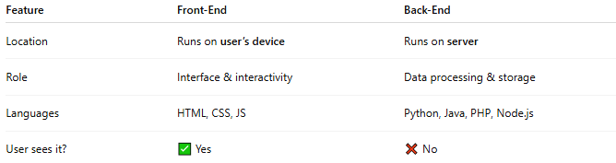
Feature | Front-End | Back-End
Location | Runs on user’s device | Runs on server
Role | Interface & interactivity | Data processing & storage
Languages | HTML, CSS, JS | Python, Java, PHP, Node.js
User sees it? | ✅ Yes | ❌ No

Analogy
- Front-End → The display window and counters of a store
- Customers interact with it directly, see products, and place orders

✅ Summary
- Front-End = user-facing part of an application
- Includes design, layout, and interactivity
- Built using HTML, CSS, JS, and frameworks

2-Back-End

Definition:
# Source: AI Source: Provided by: [Data Path: Persons Table -> ID Column: 1, Name_En Column: Motasem Essam] -> From: [Chatgpt (GPT‑5 Mini)] on [1/26/2026]
The back-end is the server-side part of a software application that processes data, manages the database, and handles business logic. Users do not see it directly, but it powers the front-end.

Key Points
# Source: AI Source: Provided by: [Data Path: Persons Table -> ID Column: 1, Name_En Column: Motasem Essam] -> From: [Chatgpt (GPT‑5 Mini)] on [1/26/2026]
- Also called: Server-side
- Handles:
  - Database operations (store, retrieve, update data)
  - Business logic (calculations, rules, workflows)
  - Server communication (responding to requests from the front-end)
- Runs on: Servers, not the user’s device

Back-End Technologies
# Source: AI Source: Provided by: [Data Path: Persons Table -> ID Column: 1, Name_En Column: Motasem Essam] -> From: [Chatgpt (GPT‑5 Mini)] on [1/26/2026]
- Programming Languages: Python, Java, C#, PHP, Node.js
- Databases: MySQL, PostgreSQL, MongoDB, Oracle
- Frameworks: Django, Flask, Spring, Express.js, Ruby on Rails
- Server Management: Apache, Nginx, AWS, Azure

Example
# Source: AI Source: Provided by: [Data Path: Persons Table -> ID Column: 1, Name_En Column: Motasem Essam] -> From: [Chatgpt (GPT‑5 Mini)] on [1/26/2026]
- In an e-commerce website:
  - Front-End: Displays product list
  - Back-End: Fetches product data from the database, handles user login, processes payments

Back-End vs Front-End
# Source: AI Source: Provided by: [Data Path: Persons Table -> ID Column: 1, Name_En Column: Motasem Essam] -> From: [Chatgpt (GPT‑5 Mini)] on [1/26/2026]
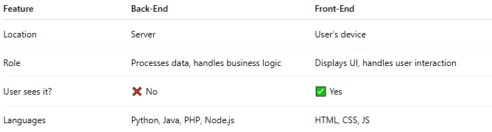
Feature | Back-End | Front-End
Location | Server | User’s device
Role | Processes data, handles business logic | Displays UI, handles user interaction
User sees it? | ❌ No | ✅ Yes
Languages | Python, Java, PHP, Node.js | HTML, CSS, JS

Analogy
# Source: AI Source: Provided by: [Data Path: Persons Table -> ID Column: 1, Name_En Column: Motasem Essam] -> From: [Chatgpt (GPT‑5 Mini)] on [1/26/2026]
- Back-End → The kitchen and staff in a restaurant
- Customers don’t see the kitchen, but it prepares the food that they order

✅ Summary
# Source: AI Source: Provided by: [Data Path: Persons Table -> ID Column: 1, Name_En Column: Motasem Essam] -> From: [Chatgpt (GPT‑5 Mini)] on [1/26/2026]
- Back-End = server-side logic and database operations
- Powers the front-end by processing requests and sending data
- Built using server languages, databases, and frameworks

